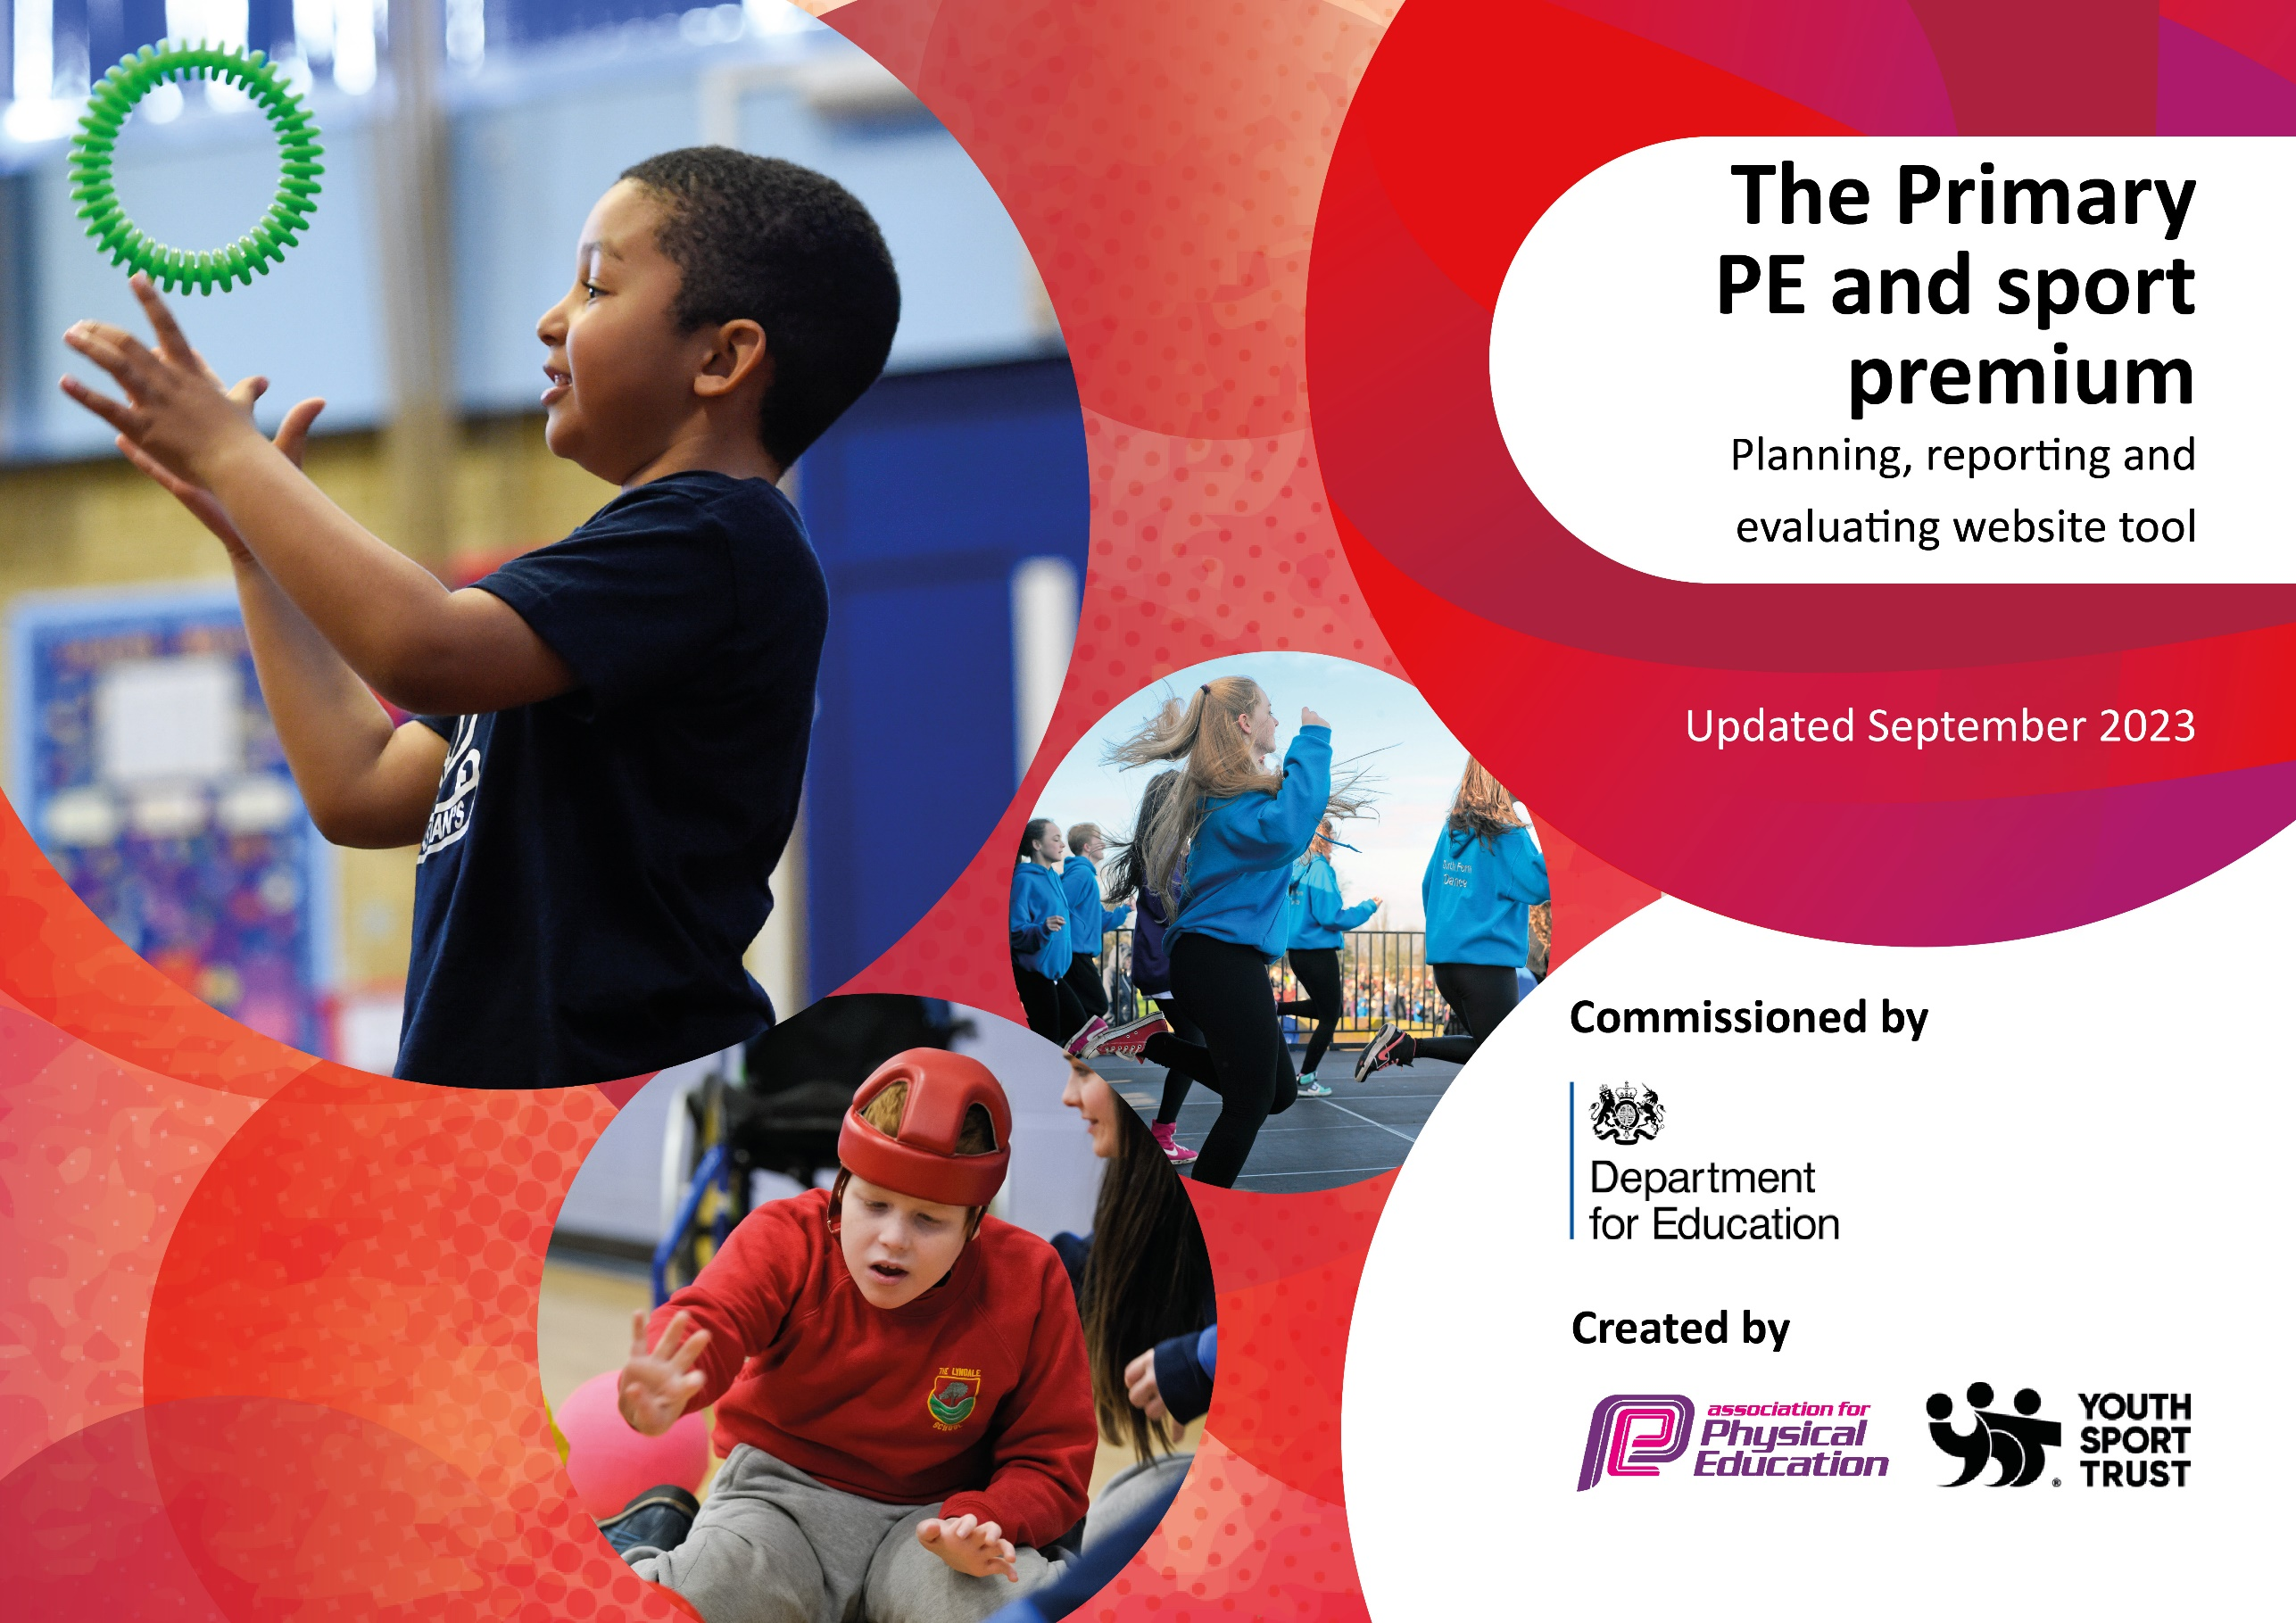

Key priorities and Planning – total Sports Premium budget: £17,800

Action – what are you planning to do | Who does this action impact? | Key indicator to meet | Impacts and how sustainability will be achieved? | Cost linked to the action
Introduce Albion Foundation coach to mentor staff. A coach to be in school all day on Tuesday & Fri. Will work over a lunchtime, supervising play in the MUGA and will also offer after school football clubs.  In the summer term introduce Cricket through the ‘Chance to Shine Programme’  This will starts in Summer 1 for 7 weeks.  ‘All stars’ cricket sessions to be offered as an after school club.  Introduction of box-clever mentoring. Is a 12-week programme.  Weekly swimming lessons for specific year groups.  MAC –wide gymnastics festival, organised by St. Mary’s with RB sport.  Balance-ability –  12 week balance bike programme for our EYFS pupils  Engagement in competitive sports fixture and events through the SGO. | Teaching staff as they will work alongside the coach.  Pupils – they will participate in the sessions.  Pupils who want to participate and parents as there will be a charge to them.  Pupils who have been identified with SEMH needs.  Pupils  Y3&4 pupils across the MAC.  Pupils  Pupils and staff | 1 – staff will gain more confidence working alongside a PE specialist.  2 -The engagement of all pupils in regular physical activity – the Chief Medical Officer guidelines recommend that all children and young people aged 5 to 18 engage in at least 60 minutes of physical activity per day, of which 30 minutes should be in school.  4 – Broader experience of a range of sports is offered.  2 -The engagement of all pupils in regular physical activity,  4 – Broader experience of a range of sports is offered.  3 – Profile of PE and Sport is raised across the school as a tool for whole school improvement.  4 – Broader experience of a range of sports offered.  4 – Broader experience of a range of sports offered.  3 – Profile of PE and Sport is raised across the school as a tool for whole school improvement.  4 – Broader experience of a range of sports offered.  2 -The engagement of all pupils in regular physical activity,  4 – Broader experience of a range of sports is offered.  5 - Increased participation in competitive sport. | Children are receiving high quality PE sessions and staff are upskilled so they can deliver PE lessons of a higher quality.  Pupils have the opportunity to be taught how to play another sport by a Cricket specialist. This will be followed up by an after-school club.  Children will have the opportunity to play cricket at lunchtimes in the summer term on the school field.  Children will be encouraged to join a local cricket club.  Children will be inspired to join the afterschool club. As part of the payment they will receive a t-shirt, bat, ball and bag.  Children who have been identified with an SEMH need will have mentoring sessions to enable them to regulate their emotions. This will positively impact on performance and behavior in the classroom.  2 classes have the opportunity to swim throughout the year. Progress is measured and shared with parents.  Opportunity for collaborative work with pupils across the MAC. Pupils get to use different equipment in a gym and perofrm on the equipment.  Pupils have the opportunity to learn how to use a balance bike. This not only helps them learn to ride a bike with pedals but also helps with core-strength and fine motor skills.  Selected children for all year groups get to participate in groups sports: football, basketball, dodgeball, netball, gymnastics. | £7,992  No cost  Cost to parents if they wish their child to participate.  £1950  £3564  £200 (inc. transport)  £2538

Key achievements 2023-2024
This template will be completed at the end of the academic year and will showcase the key achievements schools have made with their Primary PE and sport premium spending.

Activity/Action | Impact | Comments
Albion sports coach to provide CPD for staff  Chance to Shine Cricket programme  Box-clever mentoring and ASC  MAC gymnastics festival  Balanceability  Sports fixtures and activities | Staff were able to observe PE being taught so were able to upskill themselves and have more confidence to teach the knowledge and skills that the pupils require.  Pupils from Y1 – Y6 were all able to participate in Cricket lessons, taught by an expert. Children learnt the core skills and knowledge needed to make cricket accessible to them.  Positive impact on pupils with SEMH needs. Pupils were given strategies that they can use to help with their behavior. Pupils were able to talk about their feelings and behavior in a safe space and can use this when speaking with other adults and pupils in the school.  All Reception pupils participated in this 10-week programme. There were 4 pupils that were able to ride a pedal bike proficiently at the start of the programme. By the end of the programme 26/28 pupils were able to ride a pedal bike confidently.  We achieved the Gold School Games award!  All pupil groups represented the school at many events throughout the year. It was important to us that pupils who do not necessarily play sports outside of school got the opportunity to experience a sporting competition and learn how to be a team player.  The MAC wide gymnastics competition, organized by our PE leader, was a huge success and the pupils benefitted positively from being with other pupils in our MAC family. | The CPD for staff also allowed them the opportunity to have quality time to observe the children and therefore make accurate assessments to inform future lessons and planning.  This is a fantastic scheme and allows pupils to play a sport which they might not usually play. The Chance to Shine programme also encourages pupils and families to find out more about their local cricket club and the ‘All Stars’ and ‘Dynamos’ programmes they run.  A group of pupils were identified to participate in this mentoring. At the end of the block of sessions the pupils visited the Boxing gym and took part in a session. The positive impact of the mentoring was seen in school and there were fewer incidents of negative behavior. The sessions would need to continue over a longer period of time to see and evaluate long-term impact. The ASC was successful as it was something different that was being offered. Free places were offered to identified disadvantaged or vulnerable pupils.  The puoils were assessed at the start and end of the programme, They were taught in groups 7/8 and had a session each week. At the end of the programme we invited parents to bring in their child’s bike and watch what the children had learnt. For those children without a bike at home they were able to borrow one. It was a real showcase of achievement and the parents were amazed at the progress the children had made. This was a real success this year and has already been booked for 24/25.  The PE leader worked tirelessly to ensure that as many children as logistically possible were able to participate in sporting competitions. These were held in various different locations around Sandwell.

Swimming Data

Meeting National Curriculum requirements for swimming and water safety.
Priority should always be given to ensuring that pupils can perform safe self-rescue even if they do not fully meet the first two requirements of the National Curriculum programme of study

Question | Stats: | Further context  Relative to local challenges
What percentage of your current Year 6 cohort can swim competently, confidently and proficiently over a distance of at least 25 metres? | % | Use this text box to give further context behind the percentage.  e.g., 30% - we are struggling to get pool space due to our local pool closing so we have had to use a much smaller local school pool. We have had to limit the number of pupils attending swimming lessons during one term which means some pupils have attended fewer swimming lessons than others.
What percentage of your current Year 6 cohort can use a range of strokes effectively [for example, front crawl, backstroke, and breaststroke]? | %
What percentage of your current Year 6 cohort are able to perform safe self-rescue in different water-based situations? | %
If your schools swimming data is below national expectation, you can choose to use the Primary PE and sport premium to provide additional top-up sessions for those pupils that did not meet National Curriculum  requirements after the completion of core lessons. Have you done this? | Yes/No | This year we made the decision that one class would swim for the whole year – this is our Y4 class. Those children that do not meet the NC requirements will be given the opportunity to swim again before they leave Y6.
Have you provided CPD to improve the knowledge and confidence of staff to be able to teach swimming and water safety? | Yes/No | Pupils at St. Mary’s have weekly swimming lessons at Wednesbury Leisure Centre. They are taught by 2 qualifies swimming instructors.

Signed off by:

Head Teacher: | Amy Pritchard
Subject Leader or the individual responsible for the Primary PE and sport premium: | JulieAnne Boyce
Governor: | Mike Moran – Pupil and Sports Premium link governor
Date: | July 2024

